Jacob Alspaw

EECS 325 Networks I

Assignment 2

5 October 2016

***Answer1:***

When I am on Case campus, the default configuration, which utilizes a DNS resolver provided by the Case network, will result in better performance when I attempt to obtain content from a website that subscribes to a conventional content delivery network. If we assume that the time between the moment the resolver receives a DNS query and the moment it sends out the response back are the same, then we can eliminate any differences in CPU or memory sizes, or differences in cache hit rates. The last deciding factor is the location of the DNS resolvers. The Case DNS resolver will always be closer, so transmission times will be kept to a minimum as opposed to a public DNS resolution service.

***Answer 2:***

Without Proxy: 2s

With Proxy: (40%) * 100ms + (60%) * 2.05s = 1.27s

On average, deploying a proxy server will decrease response time by 0.73 seconds.

***Answer 3A:***

The DNS will need:

“A” record for www.foo.com mapping to IP address 160.50.1.1

“CNAME” record in the DNS for movies.foo.com to cdn.net.

***Answer 3B:***

Before the HTTP client process initiates a TCP connection to the server, the client needs to have a mapping from the host (foo.com) to the corresponding IP Adress. A request to the user’s DNS server will determine IP address associated with the domain name. Since there is no caching, it then needs to check the root DNS server. The domain extension is “.com”, so the root sends it to the Top-Level Domain (TLD) DNS server which has a list of “.com” DNS servers, including *foo.com*, which then gives the IP address off the authoritative DNS server (e.g. dns.foo.com). There, we will have the actual DNS records of *foo.com*, including the A record which directly maps to the IP Adress. The DNS will return to the user the IP address 160.50.1.1, so the user can initiate the TCP connection to the server on the default port 80. The HTTP client can then send a HTTP Get request message to the server like the one below.

GET /home.html HTTP/1.1

Host: www.foo.com

The HTTP server receives the request message via its socket, retrieves the object, encapsulates it in an HTTP response message, and sends that back to the client via its own socket. When the HTTP client receives the response message, the TCP connection terminates and the client extracts the HTML file (or other types) from the response message that it received.

***Answer 3C:***

The application level-exchange for the given URL draws similarities to part B, but the DNS process differs. After reaching the authoritative DNS server, the record retrieved is for *movies.foo.com*. It will instead receive a CNAME record to cdn.net. The browser must then request the host of cdn.net, which is not cached. Therefore, the request must go through the root DNS server and TDL DNS server again until it reaches the DNS records for cdn.net. These records will presumably return an IP address. The HTTP client then goes through the same message exchange process as in part B and extracts the HTML file (or other types) from cdn.net.

GET /topten.html HTTP/1.1

Host: movies.foo.com

***Answer 4A:***

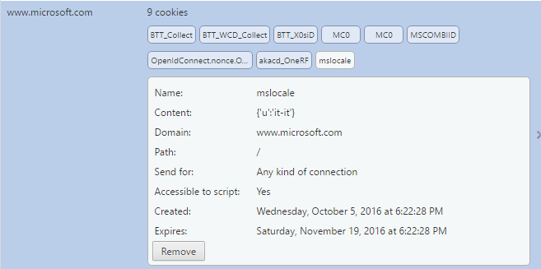

The main purpose of a cookie is to identify users and possibly prepare customized webpages or to save site login information for your subsequent visits. The above picture is an example of a Microsoft Cookie whose content has changed my default language preferences to Italian. Every time I request to view www.Microsoft.com, the cookie will be used by the domain to support my language preferences and direct me to https://www.microsoft.com/it-it/. Other information about myself or my computer can be stored on any of the other computers.

***Answer 4B:***

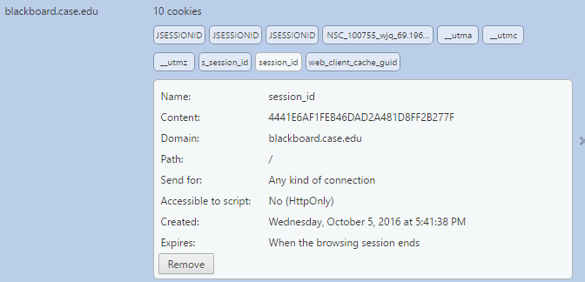

Cookies will allow an authorized user to revisit the site without a repeated log-in procedure. When the user logs in, a *session ID* will be stored in a cookie on the client's computer (not the username or password). Instead, it will be some form of string hashed by an encryption function. My hashed string is found above in the content section of the “session_Id” cookie. On the server side, the session may be tied to an IP address w­ithin a database­, so an individual session ID only works with the computer it was started on. This will improve computer security.

***Answer 4C:***

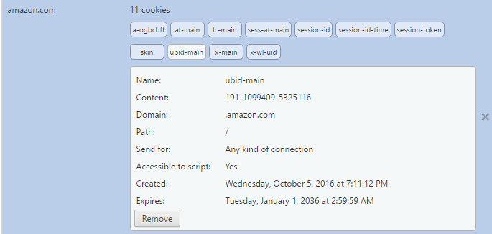

Cookies tell the server what pages to show the user so the user doesn't have to remember or start navigating the site all over again. Cookies act as a sort of “bookmark” within the site. Similarly, cookies can store ordering information needed to make shopping carts work instead of forcing the user to remember all the items the user put in the shopping cart. The above cookie is an example of a cookie that remembers the user’s shopping cart when they aren’t logged in. It will link the temporary shopping cart information to a server side database entry. Items in the shopping cart influence the items that Amazon will market to a user. Therefore, the cookie will track user access patterns within the website.

***Answer 4D:***

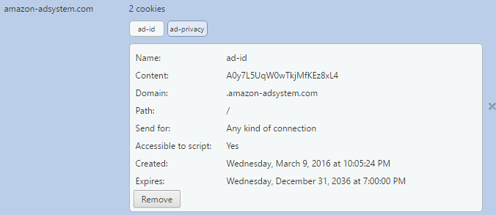

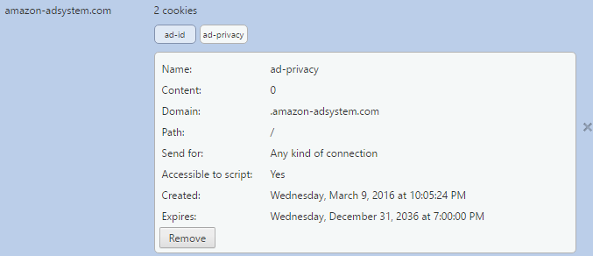

**content-security-policy:**

default-src * data: blob:;script-src *.facebook.com *.fbcdn.net *.facebook.net *.google-analytics.com *.virtualearth.net *.google.com 127.0.0.1:* *.spotilocal.com:* 'unsafe-inline' 'unsafe-eval' fbstatic-a.akamaihd.net fbcdn-static-b-a.akamaihd.net *.atlassolutions.com blob: data:;style-src data: 'unsafe-inline' *;connect-src *.facebook.com *.fbcdn.net *.facebook.net *.spotilocal.com:* *.akamaihd.net wss://*.facebook.com:* https://fb.scanandcleanlocal.com:* *.atlassolutions.com attachment.fbsbx.com ws://localhost:* blob: *.cdninstagram.com chrome-extension://boadgeojelhgndaghljhdicfkmllpafd chrome-extension://dliochdbjfkdbacpmhlcpmleaejidimm;

Amazon has a separate section of cookies for their third-party partnerships. The first cookie will track which adds are most suitable (stored in a hashed value) based on my viewing habits on Amazon’s partner sites like Facebook. The second cookie, aptly named “ad-privacy”, has a content value of 0 or false, meaning I have declined privacy and have allowed Amazon access to my viewing habits. As we can see in the HTTP Header Field labeled “content-security-policy”, Facebook has allowed Google-analytics access to monitor user patterns. Therefore, the cookie and HTTP Header has allowed a company to track user accesses across partner sites.

***Answer 5A:***

Number of users: 100

User Internet connection speed: 1 Mbps

Movie size: 5 GB

Server Internet connection speed: 10 Mbps

Approach: Distribute the movie to 10 users at a time, 10 times over.

Cost to send 10 users the movie: (5 GB * 10 Users) / (10 Mbps * (1 Byte / 10 bits)) = 50,000 seconds

Total cost to send movie to all users: 10 * 50,000 seconds = 500,000 seconds

***Answer 5B:***

Assuming that transmission, propagation, and processing delays are neglected, then each user will be receiving the data simultaneously in a peer to peer network. Therefore, the 10 Mbps internet connection and movie is being shared throughout the network at a constant 1 Mbps rate. 90 users will be peers to other users and 10 will directly receive data from the server. All users will receive their completed copy of the movie at the same time.

Approach: Distribute the movie to 100 users simultaneously over a peer network.

Total cost to send movie to all users: 5 GB / (1 Mbps * (1 Byte / 10 bits)) = 50,000 seconds

***Answer 6A:***

Yes. His claim is possible as long as he has access to enough peers for the duration of his free ride. Bob can always receive data through optimistic unchoking from peers that will continue to choose Bob to trade data with until the peer finds a better partner. There is a 1 in 5 chance that Bob will receive a free ride from another partner, so the download speeds will likely be slow.

***Answer 6B:***

Bob can make his “free-riding” more efficient by running a torrenting client on each of his new computers with distinct IP addresses. Each client can engage in its own “free ride” and then each chunk of data received from individual machines can be combined to more quickly receive torrented files. However, the same limits from problem 6A still apply to Bob.